Entity Relationship Diagram

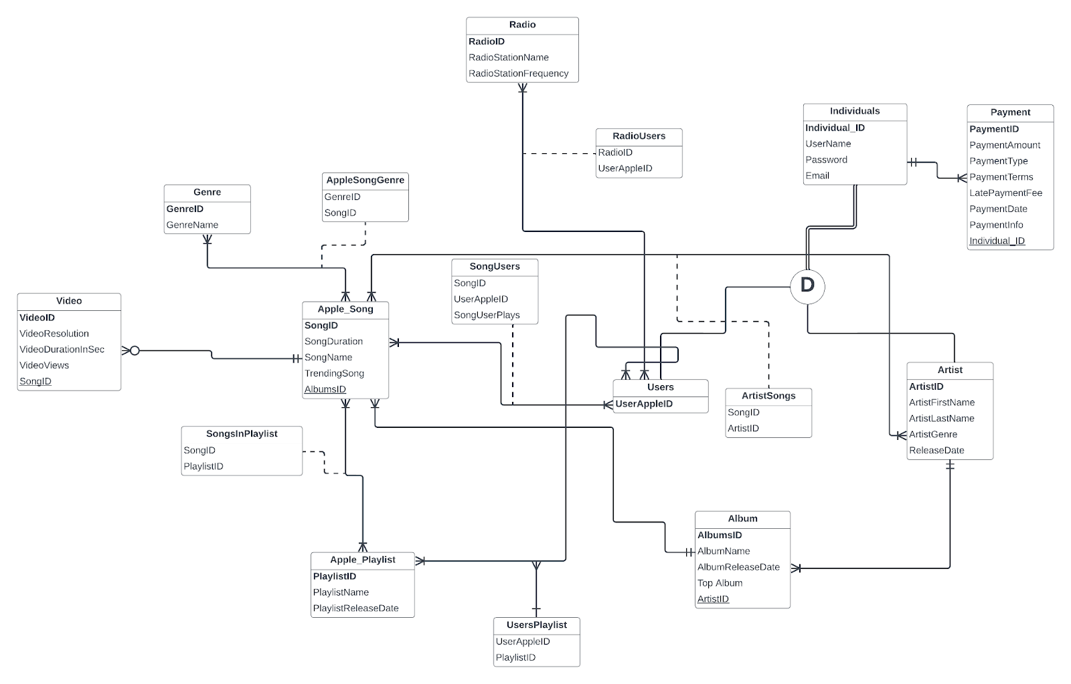

Physical Design

1-Individuals

| IndividualID | UserName | Password | Email |
| --- | --- | --- | --- |

2-Genre

| GenreID | GenreName |
| --- | --- |

3-Apple_Playlist

| PlaylistID | PlaylistName | PlaylistReleaseDate |
| --- | --- | --- |

4-Radio

| RadioID | RadioStationName | RadioStationFrequency |
| --- | --- | --- |

5-Users

| *UserAppleID* |
| --- |

6-Artist

| ArtistID | ArtistFirstName | ArtistLastName | ArtistGenre | ReleaseDate |
| --- | --- | --- | --- | --- |

7-Album

| AlbumsID | AlbumName | AlbumReleaseDate | TopAlbum | *ArtistID* |
| --- | --- | --- | --- | --- |

8-Payment

| PaymentID | Payment Amount | PaymentType | PaymentTerms | LatePaymentFee | PaymentDate | Payment  Info | *IndividualID* |
| --- | --- | --- | --- | --- | --- | --- | --- |

9-Apple_Song

| SongID | SongDurationInSec | SongName | TrendingSong | *AlbumsID* |
| --- | --- | --- | --- | --- |

10-Video

| VideoID | VideoResolution | VideoDurationInSec | VideoViews | *SongID* |
| --- | --- | --- | --- | --- |

11-RadioUsers

| *RadioID* | *UserAppleID* |
| --- | --- |

12-ArtistSongs

| *ArtistID* | *SongID* |
| --- | --- |

13-SongUsers

| *SongID* | *UserAppleID* | SongUserPlays |
| --- | --- | --- |

14-AppleSongGenre

| *GenreID* | *SongID* |
| --- | --- |

15-SongsInPlaylists

| *PlaylistID* | *SongID* |
| --- | --- |

16-UsersPlaylist

| *PlaylistID* | *UserAppleID* |
| --- | --- |

**Phase 3: Physical Database Design**

**1-Individuals**

| **Column** | **Data Type** | **Constraint?** | **Default Values?** | **Index?** |
| --- | --- | --- | --- | --- |
| IndividualID | char(8) | Primary Key | No Default Value | Assumed (Primary Key) |
| UserName | varchar2(30) | Not Null, Unique | No Default Value |  |
| Password | varchar2(30) | Not Null | No Default Value |  |
| Email | varchar2(40) | Not Null, Unique | No Default Value |  |

**2-Genre**

| **Column** | **Data Type** | **Constraint?** | **Default Values?** | **Index?** |
| --- | --- | --- | --- | --- |
| GenreID | char(4) | Primary Key | No Default Value | Assumed (Primary Key) |
| GenreName | varchar2(20) | Not Null | No Default Value |  |

**3-Apple_Playlist**

| **Column** | **Data Type** | **Constraint?** | **Default Values?** | **Index?** |
| --- | --- | --- | --- | --- |
| PlaylistID | char(8) | Primary Key | No Default Value | Assumed (Primary Key) |
| PlaylistName | varchar2(30) | Not Null | No Default Value |  |
| PlaylistReleaseDate | date | Not Null | No Default Value |  |

**4-Radio**

| **Column** | **Data Type** | **Constraint?** | **Default Values?** | **Index?** |
| --- | --- | --- | --- | --- |
| RadioID | char(4) | Primary Key | No Default Value | Assumed (Primary Key) |
| RadioStationName | varchar2(30) | Not Null | No Default Value |  |
| RadioStationFrequency | number(7,3) |  | No Default Value |  |

**5-Users**

| **Column** | **Data Type** | **Constraint?** | **Default Values?** | **Index?** |
| --- | --- | --- | --- | --- |
| UserAppleID | char(8) | Primary Key,  Foreign Key refers to IndividualID in Individuals | No Default Value | Assumed (Primary Key) |

**6-Artist**

| **Column** | **Data Type** | **Constraint?** | **Default Values?** | **Index?** |
| --- | --- | --- | --- | --- |
| ArtistID | char(8) | Primary Key,  Foreign Key refers to IndividualID in Individuals | No Default Value | Assumed (Primary Key) |
| ArtistFirstName | varchar2(30) | Not Null | No Default Value |  |
| ArtistLastName | varchar2(30) | Not Null | No Default Value |  |
| ArtistGenre | varchar2(20) | Not Null | No Default Value |  |
| ReleaseDate | date |  | No Default Value |  |

**7-Album**

| **Column** | **Data Type** | **Constraint?** | **Default Values?** | **Index?** |
| --- | --- | --- | --- | --- |
| AlbumsID | char(8) | Primary Key | No Default Value | Assumed (Primary Key) |
| AlbumName | varchar2(30) | Not Null | No Default Value |  |
| AlbumReleaseDate | date |  | No Default Value |  |
| TopAlbum | varchar2(3) | Yes or No | No Default Value |  |
| ArtistID | char(8) | Foreign Key, refers to ArtistID in Artist | No Default Value |  |

**8-Payment**

| **Column** | **Data Type** | **Constraint?** | **Default Values?** | **Index?** |
| --- | --- | --- | --- | --- |
| PaymentID | char(8) | Primary Key | No Default Value | Assumed (Primary Key) |
| PaymentAmount | number(6, 2) | Not Null | No Default Value |  |
| PaymentType | varchar2(20) | Not Null | Credit, someone cannot use Apple Music without some form of payment |  |
| PaymentTerms | varchar2(30) | Not Null | No Default Value |  |
| LatePaymentFee | number(3,2) |  | 0, Assumed No Late Payments |  |
| PaymentDate | date |  | No Default Value |  |
| PaymentInfo | varchar2(20) | Not Null | No Default Value |  |
| IndividualID | char(8) | Foreign Key,  refers to IndividualID in Individual | No Default Value |  |

**9-Apple_Song**

| **Column** | **Data Type** | **Constraint?** | **Default Values?** | **Index?** |
| --- | --- | --- | --- | --- |
| SongID | char(8) | Primary Key | No Default Value | Assumed (Primary Key) |
| SongDurationInSec | number(8) | not null, < 0 | Default Value is 0.1, since a song cannot be zero seconds long |  |
| SongName | varchar2(40) | Not Null | No Default Value |  |
| TrendingSong | varchar2(3) | Not Null, Yes or No | No Default Value |  |
| AlbumsID | char(8) | Foreign Key,  refers to AlbumsID in Album | No Default Value |  |

**10-Video**

| **Column** | **Data Type** | **Constraint?** | **Default Values?** | **Index?** |
| --- | --- | --- | --- | --- |
| VideoID | char(8) | Primary Key | No Default Value | Assumed (Primary Key) |
| VideoResolution | number(5) | Not Null, >=240 | Default Value is 240p, since the video has to have a minimum resolution |  |
| VideoDurationInSec | number(8) | Not Null, >0 | No Default Value |  |
| VideoViews | number(12) | Not Null | No Default Value |  |
| SongID | char(8) | Foreign Key refers to SongID in Apple_Song | No Default Value |  |

**11-RadioUsers**

| **Column** | **Data Type** | **Constraint?** | **Default Values?** | **Index?** |
| --- | --- | --- | --- | --- |
| RadioID | char(4) | Primary Key,  Foreign Key  refers to RadioID in Radio | No Default Value | Assumed (Primary Key) |
| UserAppleID | char(8) | Primary Key,  Foreign Key  refers to UserAppleID in Users | No Default Value | Assumed (Primary Key) |

**12-ArtistSongs**

| **Column** | **Data Type** | **Constraint?** | **Default Values?** | **Index?** |
| --- | --- | --- | --- | --- |
| ArtistID | char(8) | Primary Key,  Foreign Key  refers to ArtistID in Artist | No Default Value | Assumed (Primary Key) |
| SongID | char(8) | Primary Key,  Foreign Key  refers to SongID in Apple_Song | No Default Value | Assumed (Primary Key) |

**13-SongUsers**

| **Column** | **Data Type** | **Constraint?** | **Default Values?** | **Index?** |
| --- | --- | --- | --- | --- |
| UserAppleID | char(8) | Primary Key,  Foreign Key  refers to UserAppleID in Users | No Default Value | Assumed (Primary Key) |
| SongID | char(8) | Primary Key,  Foreign Key  refers to SongID in Apple_Song | No Default Value | Assumed (Primary Key) |
| SongUserPlays | number(6) |  | No Default Value |  |

**14-AppleSongGenre**

| **Column** | **Data Type** | **Constraint?** | **Default Values?** | **Index?** |
| --- | --- | --- | --- | --- |
| GenreID | char(4) | Primary Key,  Foreign Key  refers to GenreID in Genre | No Default Value | Assumed (Primary Key) |
| SongID | char(8) | Primary Key,  Foreign Key  refers to SongID in Apple_Song | No Default Value | Assumed (Primary Key) |

**15-SongsInPlaylist**

| **Column** | **Data Type** | **Constraint?** | **Default Values?** | **Index?** |
| --- | --- | --- | --- | --- |
| PlaylistID | char(8) | Primary Key,  Foreign Key  refers to PlaylistID in Apple_Playlist | No Default Value | Assumed (Primary Key) |
| SongID | char(8) | Primary Key,  Foreign Key  refers to SongID in Apple_Song | No Default Value | Assumed (Primary Key) |

**16-UsersPlaylist**

| **Column** | **Data Type** | **Constraint?** | **Default Values?** | **Index?** |
| --- | --- | --- | --- | --- |
| PlaylistID | char(8) | Primary Key,  Foreign Key  refers to PlaylistID in Apple_Playlist | No Default Value | Assumed (Primary Key) |
| UserAppleID | char(8) | Primary Key,  Foreign Key  refers to UserAppleID in Users | No Default Value | Assumed (Primary Key) |